**GUJARAT TECHNOLOGICAL UNIVERSITY**

Chandkheda, Ahmedabad

Affiliated



SHANTILAL SHAH ENGINEERING COLLEGE

A Report On-

SMART ASSISTANCE

Under

B. E. IV, Semester – VII

INFORMATION & TECHNOLOGY

Submitted by:

TEAM ID: 59655

Sr. Name of student Enrolment No.

1. Ghanta Sarfaraz 130430116031

1. Jadeja Harshvardhansinh 130430116043

**D D Sanghani**

(Faculty Guide)

**Prof. B. V. Buddhdev**

Head of the Department

Academic year

(2016-2017)



**CERTIFICATE**

This is to certify that the work embodied in this thesis entitled “**SMART ASSISTANCE”** was carried out by **Ghanta Sarfaraz (130430116031)** at **Information Technology Department** of **Shantilal Shah Engineering College, Bhavnagar** in Partial Fulfilment of the Requirements for the Degree of B.E. to be awarded by Gujarat Technological University. This work has been carried out under my supervision and it is up to my satisfaction.

Date:

Place: Bhavnagar

|  |  |  |
| --- | --- | --- |
| **D D Sanghani**  Asst. Professor(IT),  SSEC ,Bhavnagar |  | **Prof. B. V. Buddhdev**  HOD,  Information Technology Department  SSEC ,Bhavnagar |



**CERTIFICATE**

This is to certify that the work embodied in this thesis entitled “**SMART ASSISTANCE”** was carried out by **Jadeja Harshvardhansinh (130430116043)** at **Information Technology Department** of **Shantilal Shah Engineering College, Bhavnagar** in Partial Fulfilment of the Requirements for the Degree of B.E. to be awarded by Gujarat Technological University. This work has been carried out under my supervision and it is up to my satisfaction.

Date:

Place: Bhavnagar

|  |  |  |
| --- | --- | --- |
| **D D Sanghani**  Asst. Professor(IT),  SSEC ,Bhavnagar |  | **Prof. B. V. Buddhdev**  HOD,  Information Technology Department  SSEC ,Bhavnagar |

**ACKNOWLEDGEMENT**

Every work that one completes successfully sends on the constant encouragement, good will and support of the people around. I, hereby, avail this opportunity of express my heartfelt gratitude to a number of people who extended their valuable time, full support and co-operation and developing this project.

I would like to place on record our deep sense of gratitude to Prof.**B.V.BUDHDEV**, HOD-Dept. of Information & Technology Engineering, SSEC, Bhavnagar, for his generous guidance, help and useful suggestions.

I express our sincere gratitude to Prof. **D D Sanghani**, Dept. of Information & Technology Engineering, SSEC, Bhavnagar, for her stimulating guidance, continuous encouragement and supervision throughout the course of present work.

I also wish to extend our thanks to our family and other colleagues for attending our seminars and for their insightful comments and constructive suggestions to improve the quality of this report work.

.

**Prepared by:**

**Ghanta Sarfaraz M (130430116031)**

**Jadeja harshvardhansinh G (130430116043)**

**Abstract**

Now a days we require to visit many types of service provider like doctor, hair dresser, astrologer, charter accountant, lawyer, beautician etc. all this types of service provider are busy if they are popular in their business. And getting appointment is headache for anyone, once you get appointment you have to wait for 1 or 2 hour to get your turn for one to one talk and get treatment or consultation from experts. So this problem can be solved with help of kind a unique app we called it “Smart Assistance”.

Smart Assistance is app which allows service provider and consumer to send and receive notification about their upcoming appointments as well as it can be also used to book appointments.

Main features of application will be:

1) In-app appointment booking & confirmation and in app notification about your turn

2) Manage queue of clients in waiting for professionals listed above

3) Client can also pay online, if they wish

4) Provide facility to service provider to create the profile and rate card

5) Maintain queue for service provider

6) One click super easy turn intimation to client

7) Provide facility to client to write review about their experience.

**INDEX**

|  |  |  |
| --- | --- | --- |
| **Sr. No** | **TOPIC** | **Page No** |
| **1** | **INTRODUCTION** |  |
|  | 1.1 Project Profile |  |
|  | 1.2 Project Definition |  |
|  | 1.3 Project Aim |  |
|  | 1.4 Project Purpose |  |
|  | 1.5 Project Scope |  |
|  | 1.6 Project Module & Literature Review |  |
| **2** | **SYSTEM REQUIRENMENT STUDY** |  |
|  | 2.1 Hardware and Software Requirement |  |
| **3** | **PROJRCT MANAGEMENT** |  |
|  | 3.1 Project Planning |  |
|  | 3.2 Time Line Chart |  |
|  | 3.3 Process Model |  |
| **4** | **SYSTEM ANALYSIS** |  |
|  | 4.1 System Analysis Overview |  |
|  | 4.2 Feasibility Study |  |
| **5** | **System Design** |  |
|  | 5.1 Design Engineering Canvas Sheets |  |
|  | 5.2 UML Diagrams |  |
| **6** | **SUMMARY** |  |
|  |  |  |
|  |  |  |

**CHAPTER: 1**

**INTRODUCTION**

**1.1 PROJECT PROFILE**

**Project Title**  **:** Smart Assistance

**Project Type** **:** Web Based Application

**Objective**  **:** To Develop an Android app onAppointment System

**Technology**  **:** Android

**Purpose**   **:** B.E.IT, (7th Semester)

**Submitted to :** Shantilal Shah Engineering College

**Developed By**  **:** Jadeja Harshvardhansinh G (130430116043)

Ghanta Sarfaraz M (130430116031)

* 1. **Problem Definition**

As we all are living in the new era of technology, it is supposed to have everything surrounding us smart and technically advanced. As in this era everybody use to have a smartphone and an increasing use of the smart android app strikes us to have everything inside an app. Every organization, private and public companies, stakeholders, universities, colleges etc. used to have their own smartphone applications.

Everybody used to complete his/her work in time and booking an appointment is one of the way to complete the work in time. Over a past few years booking an appointment has grown popularity over whole world, many organizations, businesses, universities, hospitals, hairstylist, charter accountant, astrologer etc. uses some web-based online appointment management system which helps them to have their work done on time bases.

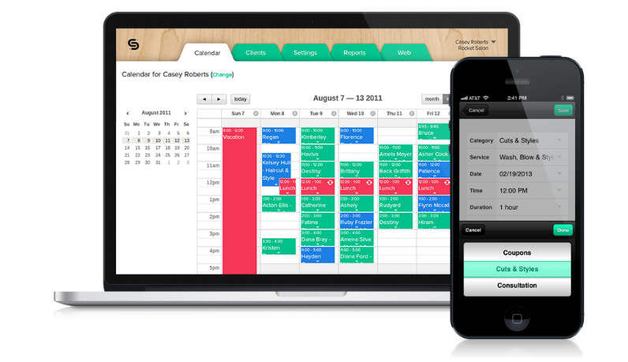

An online appointment management system allows patients to book appointment to specific doctor, a student to register and apply for book appointment, an organization to held meetings, appointments for job etc.

In This report we have discussed about creating an android app for the various places where there is likely to have a queue and booking an appointments to remove the queues.

* 1. **Project Aim**

Smart Assistance is being developed with the aim to reduce the effort of standing and waiting in a Queue while taking an appointment and to provide the smart way to book an appointment.

Also its different Aim and Objectives are as follow:

1. In-app appointment booking & confirmation and in app notification about your turn
2. Manage queue of clients in waiting for professionals like doctor, hair dresser, astrologer, charter accountant, lawyer, beautician etc.
3. Client can also pay online, if they wish
4. Provide facility to service provider to create the profile and rate card
5. Maintain queue for service provider
6. One click super easy turn intimation to client
7. Provide facility to client to write review about their experience.
8. Easy and advanced user interface.
   1. **Project Purpose:**

The Purpose to develop the app was to do something innovative in a way that it provides the facility to everyone regarding the problem faced while booking an appointment. This app will solve the problems like wastage of time, Effort of standing in a queue. It also provides the smart access and online payment facility.

**1.5 Project Scope**

The project scope is that it must achieve the basic objective of the Problem defination. Here the basic objective is to provide effortless facility for booking an appointment.

* 1. **Project module detail:**

**1 User Module:**

* User Registration
* User Login
* User Profile
* List of service Provider
* Appointment History
* Booked Appointment

**2. Service Provider Module:**

* Registration
* Login
* Request List
* Approved Request
* Booked Appointments
* Appointment History
* **Literature Review:**

1. APPOINTMENT ARBITER:

**Patent No:** 20060.129444A1

**Abstract:** The main information is about setting up the appointment. Firstly the request is sent from the client to the service provider, and then the respective receivers receives the notification and approves and rejects as per his/her schedule.

1. ON-LINE APPOINTMENT SYSTEM WITH

ELECTRONIC NOTIFICATIONS

**Patent No:** 7,188,073 B1

**Abstract:** This patent discuss about the online appointment system which is used by various organizations. Notifying via electronic mail is also the feature of the patent

**CHAPTER: 2**

**SYSTEM REQUIRENMENT STUDY**

* 1. **Hardware And Software Requirenment**:

While developing any of the android app the technical support required is the computer system or a laptop for the development of app, an android smartphone for timely checking the developed application, Android studio for coding and Emulator or Genymotion for checking the developed application.

**Hardware Requirement:**

Version 2.x

|  |  |  |  |
| --- | --- | --- | --- |
|  | **Windows** | **OS X/macOS** | **Linux** |
| **OS version** | **Microsoft Windows 10/8/7 (32- or 64-bit)** | **Mac OS X 10.9.5 or higher, up to 10.11.6 (El Capitan) or 10.12 (Sierra)** | **GNOME or KDE desktop** |
|  |  | | |
| **RAM** | **2 GB RAM minimum, 8 GB RAM recommended** | | |
| **Disk space** | **500 MB disk space for Android Studio, at least 1.5 GB for Android SDK, emulator system images, and caches** | | |
| **Java version** | **Java Development Kit (JDK) 8** | | |
| **Screen Resolution** | **1280x800 minimum screen resolution** | | |

Version 1.x

|  |  |  |  |
| --- | --- | --- | --- |
|  | **Windows** | **OS X/macOS** | **Linux** |
| **OS version** | **Microsoft Windows 10/8.1/8/7/Vista/2003/XP (32 or 64 bit)** | **Mac OS X 10.8.5 or higher, up to 10.10 to up 10.10.2 up 10.10.3 or 10.10.5 (Yosemite)** | **GNOME or KDE or Unity desktop on Ubuntu or Fedora or GNU/Linux Debian** |
| **RAM** | **2 GB RAM minimum, 4 GB RAM recommended** | | |
| **Disk space** | **500 MB disk space At least 1 GB for Android SDK, emulator system images, and caches** | | |
| **Java version** | **Java Development Kit (JDK) 7 or higher** | | |
| **Screen Resolution** | **1280x800 minimum screen resolution** | | |

For windows user it is supposed to have a system of above mentioned specification, there is no issue with the operating system version you can use any of the version either windows 7/8/10.

The main problem arises when the Availability of RAM is less than 2GB or Less, because android studio alone requires more than 1 GB RAM and if the system is having 2GB RAM than it will hangs and the system will not work perfrctly.

Even the problem arises with system having 4GB RAM, hence it is recommended to have a system with 8GB RAM, in which the tools and Android Studio will operate smoothly.

Also the disk space and the java version as above mentioned in the table.

**Software Requirement**:

1. **Android Studio:**

Android Studio is an [integrated development environment](http://searchsoftwarequality.techtarget.com/definition/integrated-development-environment) (IDE) from Google that provides developers with tools needed to build applications for the Android OS platform. Android Studio is [available for download](http://developer.android.com/develop/index.html) on Windows, Mac and Linux. The foundation for Android Studio is based on [IntelliJ IDEA](https://www.jetbrains.com/idea/).

1. **Genymotion:**

Genymotion is a third party emulator used to check the developed app before deployment. It is far better than the emulator provided by the Android Studio. It is suggested to use the Genymotion instead of the Emulator.

1. **MySQL:**

MySQL is an open-source relational database management system (RDBMS). It is used to create server side database.

1. **Wamp Server:**

Wamp Server refers to a software stack for the Microsoft Windows operating system, created by Romain Bourdon and consisting of the Apache web server, OpenSSL for SSL support, Mysql database and php programming language.)

**CHAPTER: 3**

**PROJECT MANAGEMENT**

**Project Management:**

The Most important part of the project development is its management. The management decides the success and the failure of the project. Project management includes the Project planning, project scheduling and Requirement analysis Etc.

**3.1 Project Planning:**

Every work needs a well and good planning, the work done without the planning fails to reach its destination. For the Planning of our project firstly we gathered the basic information about our Problem definition. Afterwards we decided the platform to be used for the development of the project, we finally decided to develop an android application regarding our Problem definition .Then we started reading and referring the literature about the Appointment system. Then we started planning for how to collect the data and how to manage the data. Every required data regarding to Appointment system was gathered by us and started planning to manage those data.

**3.2 Time Line Chart:**

|  |  |  |  |  |  |  |  |  |  |  |  |  |  |  |  |  |
| --- | --- | --- | --- | --- | --- | --- | --- | --- | --- | --- | --- | --- | --- | --- | --- | --- |
| **Activity** | **June** | | | | **July** | | | | **September** | | | | **October** | | | |
| **Domain Understanding** |  |  |  |  |  |  |  |  |  |  |  |  |  |  |  |  |
| **Analysis** |  |  |  |  |  |  |  |  |  |  |  |  |  |  |  |  |
| **Learning**  **Process** |  |  |  |  |  |  |  |  |  |  |  |  |  |  |  |  |
| **Design** |  |  |  |  |  |  |  |  |  |  |  |  |  |  |  |  |

**3.3 Process Model – The Incremental Model**

As we are developing the Appointment Application for the first time there is supposed to be increment in the future, the increments that are covered during the development are as follow:

**Core Application**:

The basic functionalities we have approached are to analysis our project.

* **Increment 1:**

We have implemented from designing modules as our first increments.



**Figure 4. 1incremental model**

The Incremental model encompasses the following activities:

**1. System/Information Engineering and Modeling:**

System engineering and analysis encompass requirements gathering at the system level with a small amount of top-level design and analysis. Information engineering encompasses requirements gathering at the strategic business level and at the business area level.

**2. Software requirements analysis:**

The requirements gathering process is intensified and focused specifically on software. Software requirement analysis encompasses understanding the information domain for the software as well as required function, behavior, performance and interfacing. Requirements for both the system and the software are documented and reviewed with the customer.

**3. Design:**

Software design is actually a multi-step process that focuses on four distinct attributes of a program: data structure, software architecture, interfaces representation and procedural detail. The design process translates requirements into a representation of the software that can be accessed for quality before coding begins.

**4. Code generation**

Code-generation phase translates the design into a machine-readable form.

**5. Testing**

Once code has been generated, program testing begins. The testing process focuses on the logical internals of the software, ensuring that all statements have been tested, and on the functional externals; that is, conducting tests to uncover errors and ensure that defined input will produce actual results that agree with required results.

**6. Maintenance**

Software maintenance applies to following phases in the existing program change in software due to errors. Change in software because the software must be adapted to accommodate changes in its external environment. Change in software when the customer requires functional or performance enhancements.

**CHAPTER: 4**

**SYSTEM ANALYSIS**

* 1. **System analysis overview:**

The process of gathering the information, diagnosing problems and using the needed information for the improvement of the system is said to be the system analysis. Interaction between the user and the developer is given the prime importance in the system analysis, as being a problem solving activity continues and intensive communication between user and developer is most importance.

The system is deeply studied and analyzed, as the system analysis is the important phase of any system development process .The system analyst plays the role of an interrogator and dwells deep into the working of the present system. The system is viewed as a whole and the inputs to the system are identified. The outputs from the organization are traced through the various processing that the inputs phase through in the organization.

A detailed study of these processes must be made by various techniques like Interviews, Questionnaires etc. The conclusion is an understanding of how the system functions. This system is called the existing system. Now, the existing system is taken under study and the problematic arears are strike out. The designer now functions as a problem solver and tries to sort out the difficulties that the enterprise faces. The solutions are given as a proposal. The proposal is then weighed with the existing system analytically and the best one is selected. The proposal is presented to the user for an endorsement by the user. The proposal is reviewed on user request and suitable changes are made. This loop ends as soon as the user is satisfied with the proposal.

**4.2 Feasibility study:**

* **Operation feasibility:**

As the app is developed using the android mobile operating system the user-interface (UI) will be user friendly and it is developed in such a way that a non-technical person can also operate it easily. It will be easily understandable and adaptable by everyone and also provides the widgets which help them to access it easily.

* **Technical feasibility:**

The app will be totally secured as the secured app are only alloweded to be launched at google play store. The most secure and trusted back end SQL with its advance features is used for database.

* **Schedule feasibility:**

Every project gets Success which are developed under the perfect project planning and scheduling. To provide the quality software built the work is complete before the schedule so that the work can be given before demanded. And in additional to add further more functionality, new facility and correct the errors if any remains at the end after being Used by the end user

* **Economy feasibility:**

Economic feasibility is the most frequent used method for evaluating the effectiveness of a new system. More commonly known as cost/benefits analysis, the procedure is to determine the benefits and saving that are expected from a candidate system and compare them with costs. If benefits outweigh costs, then the decision is made to design and implement the system. An entrepreneur must accurately weight the cost versus benefits before taking an action.

**6.4 Technology description:**

**1) Android:**

Android is the mobile operating system developed by Google. Essentially, Google produces the software that runs almost every other mobile phone besides Apple’s iPhone. There are also some popular Android tablets as well. Android is a linax-based software system, and similar to Linux, is free and open source software.

Android is a powerful Operating System supporting a large number of applications in [Smart Phones](http://www.engineersgarage.com/articles/smart-phones). These applications make life more comfortable and advanced for the users. Hardware that supports Android is mainly based on [ARM architecture](http://www.engineersgarage.com/articles/arm-advanced-risc-machines-processors) platform.

* These are the basics of Android applications:

* Android applications are composed of one or more application components (activities, services, content providers, and broadcast receivers)
* Each component performs a different role in the overall application behavior, and each one can be activated individually (even by other applications)
* The manifest file must declare all components in the application and should also declare all application requirements, such as the minimum version of Android required and any hardware configurations required
* Non-code application resources (images, strings, layout files, etc.) should include alternatives for different device configurations (such as different strings for different languages)

**2) MYSQL [Back end]:**

* MY SQL is currently the most popular open source database server in existence.
* On top of that, it is very common used in conjunction with PHP script to create powerful and dynamic server-side applications.
* MY SQL has been criticized in the past for not supporting all the features of other popular and more expensive Database Management System.
* However, MY SQL continues to improve with each release (currently version 5 ) and it has become widely popular with individuals and businesses of many different sizes.
* **What is database?**
* A database is a structure that comes in two categories: a flat database and a relational database. A relational database is much more oriented to the human mind and is often preferred over the flat database that are just stored on hard drives like a text file. MY SQL is relational database.
* In a relational structure database there are tables that store data. The columns define which kinds of information will be stored in the table. An individual column must be created for each type of data you wish to store (i.e. Age, Weight, Height).
* On the other hand, a row contains the actual values for these specified columns. Each row will have 1 value for each and every column. For example a table with columns (Name, Age, Weight-lbs) could have a row with the values (Bob, 65, 165). If all this relational database talk is too confusing, don’t despair. We will talk about and show a few examples in the coming lessons.
* **What use a Database?**
* Database are most useful when it comes to storing information that fits into logical categories.
* For example, say that you wanted to store information of all the employees in a company. With a database you can group different parts of your business into separated tables to help store your information logically.
* Example tables might be: Employees, Supervisors, and customers. Each table would then contain columns specific to these three areas. To help store information related to each employee, the employees table might Have the following columns: Hire, Date, Position, Age, and salary.

3) **PHP (Hypertext pre-processor)[Front end]:**

* PHP is an open source general-purpose, server-side scripting language originally designed for web development to produce dynamic web pages.
* It is one of the first development server sides scripting language to be embedded into an HTML source document rather than calling an external file to process date.
* The code is interpreter by a web server with a PHP processor module which generated the resulting web page.
* It is also has evolved to include a command a command line interface capability and can be used in standalone graphical application.
* PHP can be deployed on most web server and also as a standalone shell on almost every operating system and platform free of charge.
* A competitor to Microsoft’s active server page server side scrip engine and similar language, php is installed on more than 20 million web sites and 1 million web server.

**CHAPTER: 5**

**SYSTEM DESIGN**

* 1. **Design Engineering Canvas**

**5.1.1 AEIOU Sheet:**

AEIOU in Sheet stands for Activity, Environment, Interactions, Objects and Users.

* 1. Activity:

It includes the various activity performed in the project

Activity is divided in the two parts:

1. User Activity: Activity performed at the user side

* Register/login
* Find the service provider
* Find the specialist
* Check time availability
* Request for appointment
* Feedback

1. Service Provider Activity: Activity performed at the Service providers end

* Checks notification
* Approve appointment
* Reject appointment
* Check history
  + 1. **Environment Sheet:**

Environment Sheet includes the technology used in the front-end and the back- end i.e: JAVA, XML, SQLite, MYSQL, Android, PHP

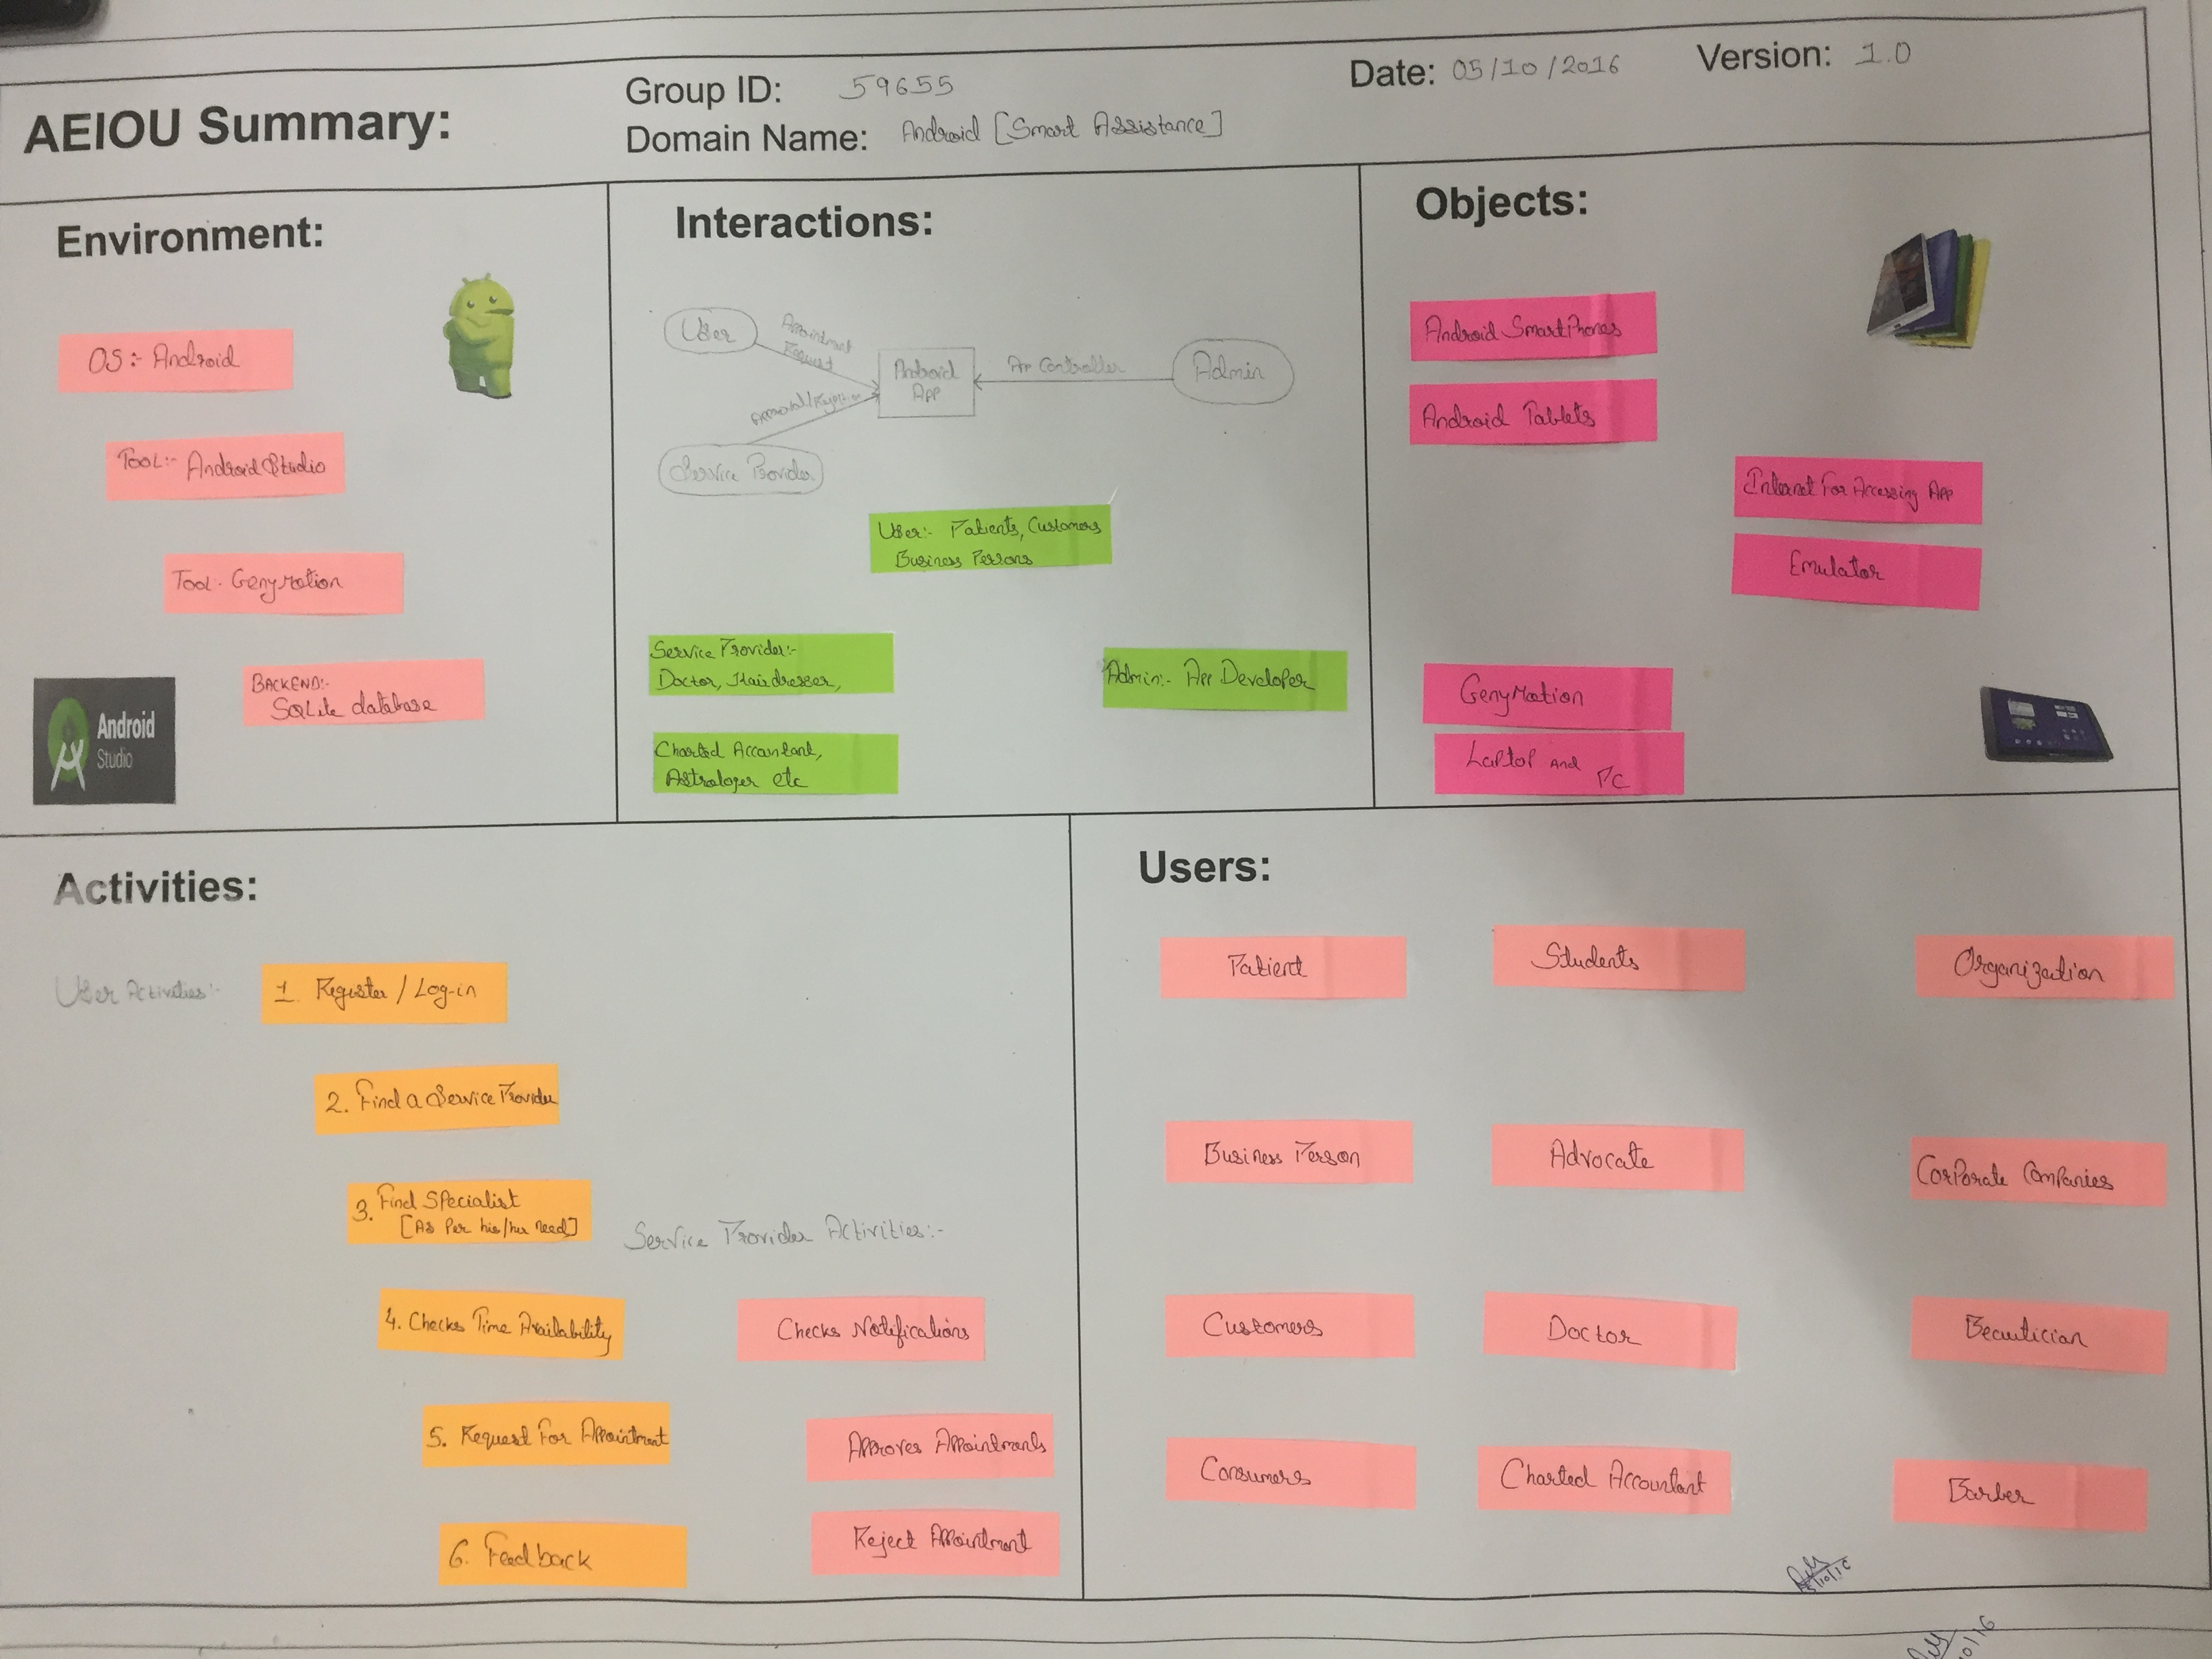

1. **Interactions Sheet:**

Interaction sheets defines the interaction between the user and the service provider

* Firstly the user request for the appointment
* And the Service provider Approves/rejects according to his/her schedule.

1. **Object Sheet:**

Object Sheet includes the objects likely to be used in the projects

* Android smartphones
* Android tablets
* Computer system
* Laptop
* Internet for accessing the app

1. **Users Sheet:**

Users sheet includes the users that are supposed to be interact in the project

* Doctors
* Patients
* Advocates
* Customers
* Consumers
* Organization
* Corporate company
* Beautician
* Students
* Charted accountant
* Hair dresser

**2) Empathy Mapping:**

Empathy mapping Sheet includes:

1. Users
2. Stakeholders
3. Activities
4. Story boarding

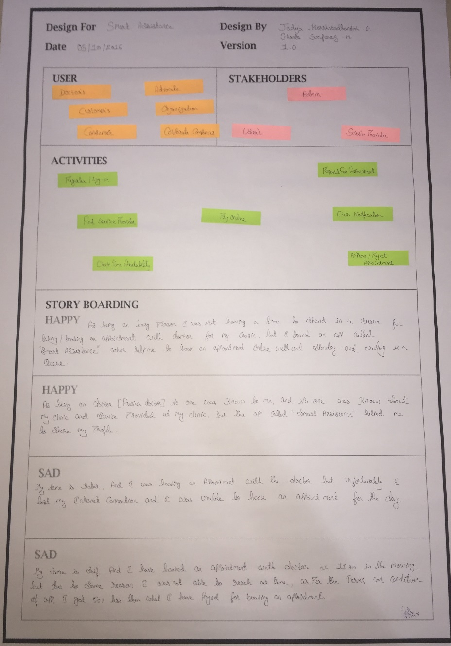

* Users:
* Doctor
* Patient
* Organization
* Corporate company
* Advocate
* Customers Etc.
* Stakeholders:
* Admin
* Users
* Service Provider
* Activities:
* Register/Log-in
* Find Service Provider
* Check Time Availability
* Request For Appointment
* Check Notification
* Approve/Reject Appointment
* Story Boarding:
* Happy: As being a busy person i was not having a time to stand in a queue for booking appointment with doctor for my cousin, but I found an app called “Smart Assistance” which helped me to book my appointment without waiting in a queue.
* Happy: As being a fresher doctor no one was known to me and no one was known about the service provided at my clinic, but this app helped me to share my profile
* Sad: My name is kabir, and I was booking an appointment with doctor but unfortunately I lost my internet connection and I was not able to book appointment for the day.
* Sad: My name is Saif, and I was having an appointment with the doctor at 11am in the morning, but due to some reason I was not able to reach at time, as per the terms and conditions of app, I got 50% less than what I have paid for appointment.

**3) Product Development Canvas:**

It includes the below stated points:

1. Purpose
2. People
3. Product experience
4. Product features
5. Product functions
6. Components
7. Customer revalidation
8. Reject, Redesign, Retain

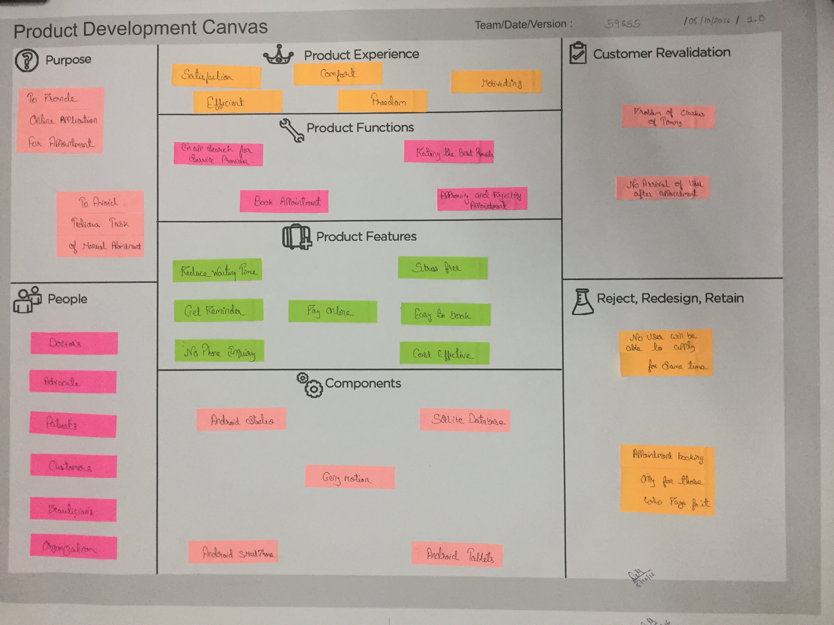

1. **Purpose:**

* To provide online application for appointment
* To avoid Tedious task of manual appointment

1. **Product Experience:**

* Comfort
* Efficient
* Motivating
* Satisfaction

1. **Product Features:**

* Reduce waiting time
* Get reminder
* Pay online
* No phone inquiry
* Stress free
* Easy to book
* Cost effective

1. **Customer revalidation:**

* Problem of clashes of time
* No arrival of user after booking appointment

1. **Redesign, Retain, Reject:**

* No user will be allowed to book for same time
* Booking an appointment only for those who pay for it

1. **Ideation canvas:**

It includes the below stated Points:

1. People
2. Activities
3. Situations/Context/location
4. Props/Possible solutions

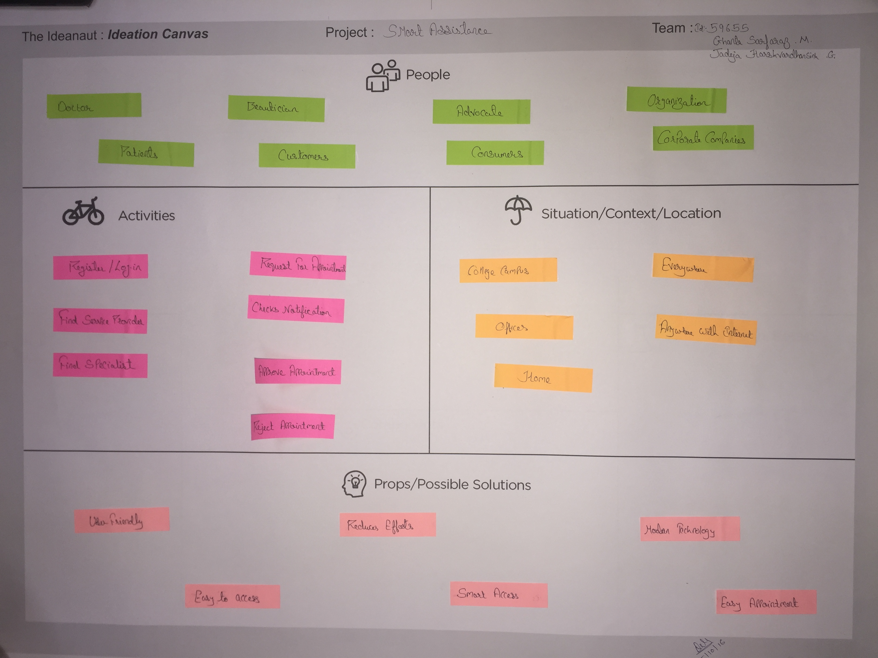

1. **People:**

* Doctor
* Patient
* Beautician
* Organization
* Corporate company Etc.

1. **Activities:**

* Register/Login
* Find service provider
* Check time availability
* Request appointment
* Check notifications
* Approve/Reject appointment

1. **Situation:**

* College campus
* Home
* Office
* Everywhere

1. **Props:**

* User friendly
* Easy to access
* Reduce efforts
* Smart access
* Easy appointment
* Modern technology

* 1. **UML- Diagrams**

1. **Activity Diagram:**

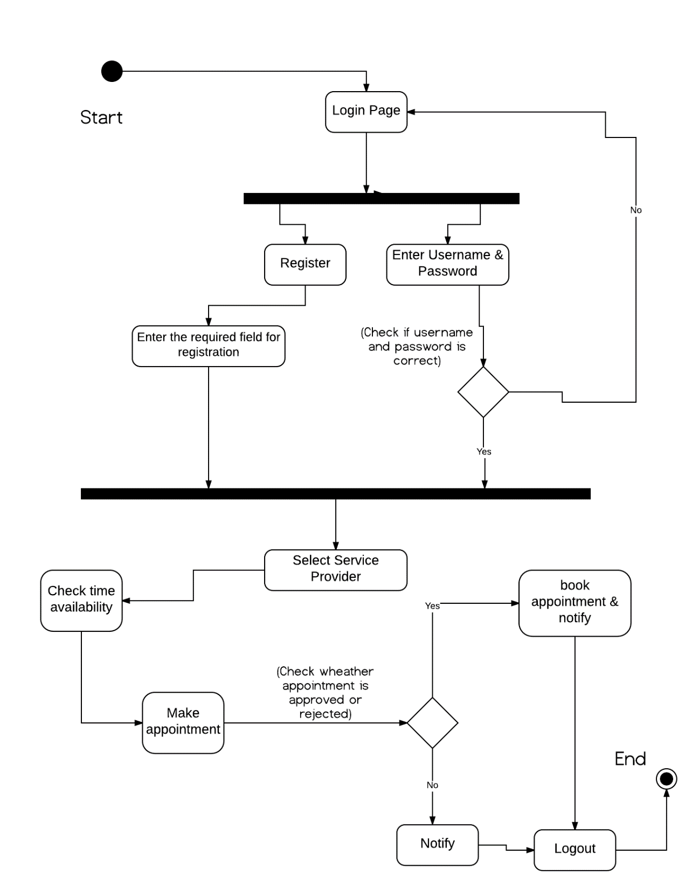

1. **Class Diagram:**

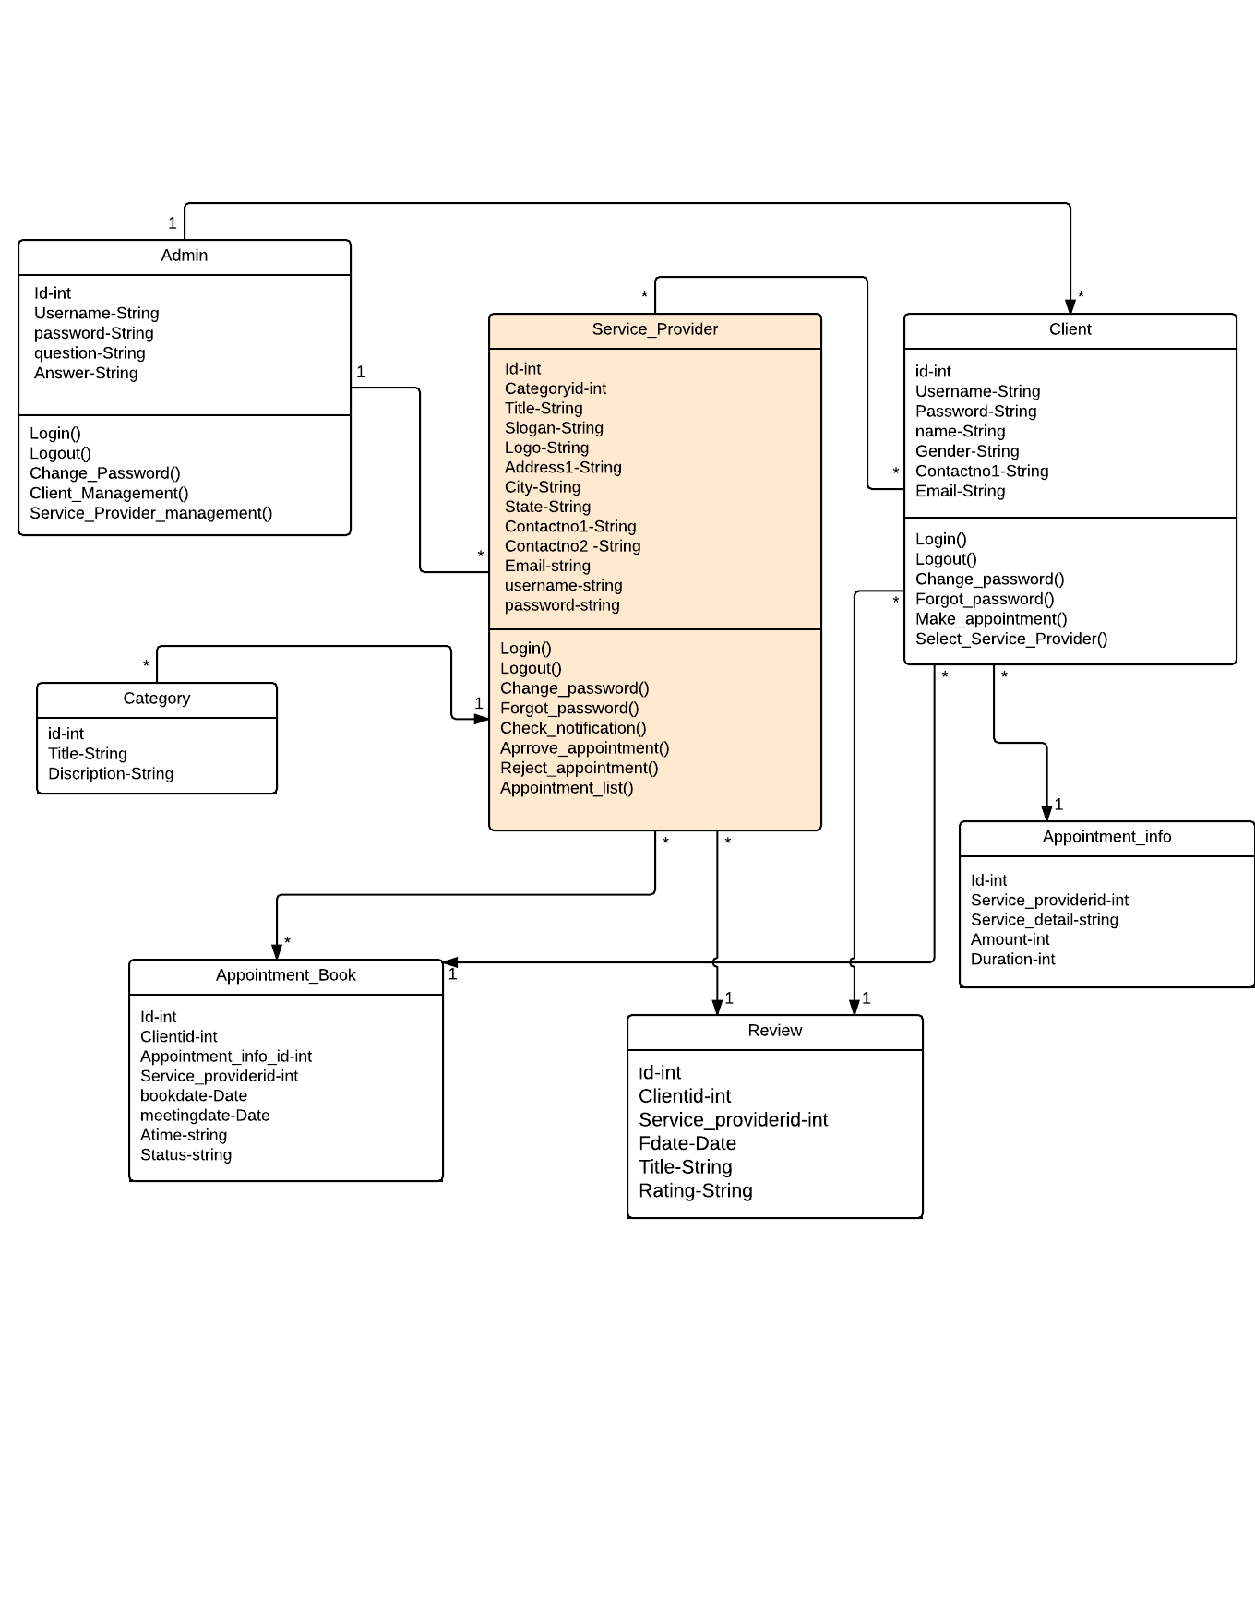

1. **Use-Case Diagram:**

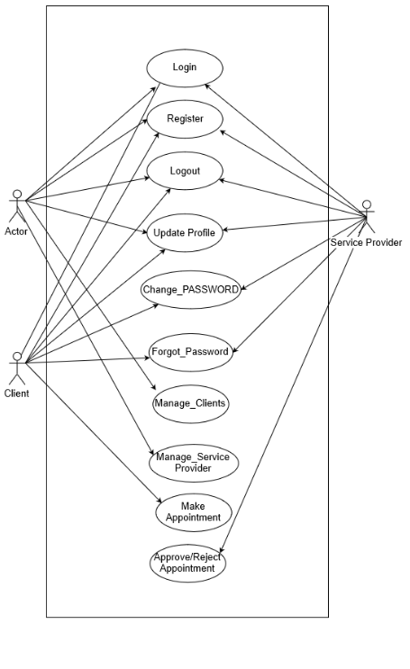

1. **ER Diagram:**

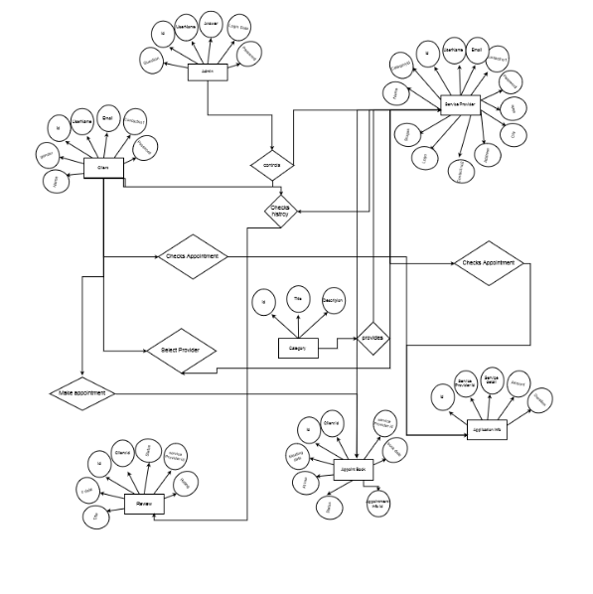

1. **Sequence Diagram:**

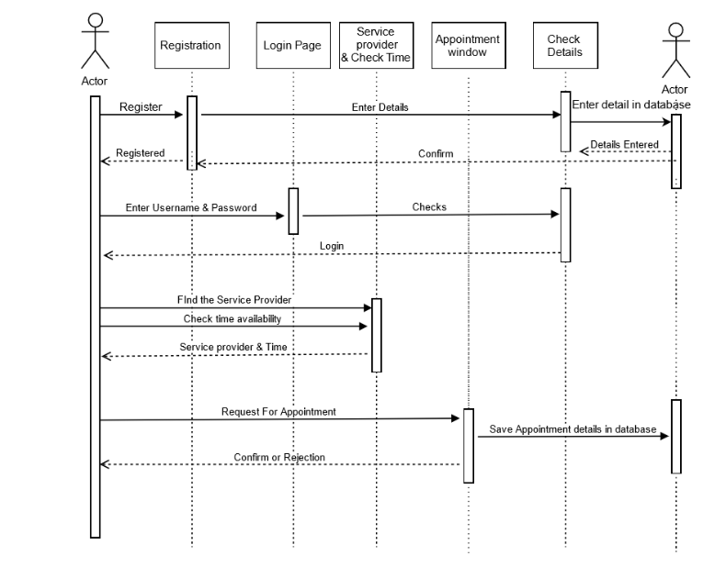

* **Data Dictionary (Database)**

1. **Review:**

|  |  |  |  |  |
| --- | --- | --- | --- | --- |
| **Review** | | | | |
|  | Id | Integer | Primary key | Uniquely identify each record |
|  | Clientid | Integer | Foreign key |  |
|  | Service_providerid | Integer | Foreign key |  |
|  | Fdate | Date | Not null | Date of feedback |
|  | Title | Varchar(128) | Not null | Title of the feedback |
|  | rating | Varchar(128) | Not null | Description of feedback |

1. **Appointment Book:**

|  |  |  |  |  |
| --- | --- | --- | --- | --- |
| **appointment_book 5** | | | | |
|  | Id | Integer | Primary key | Uniquely identify each record |
|  | Clientid | Integer | Foreign key | Foreign key of client table |
|  | Appointment_info_id | Integer | Foreign key |  |
|  | Service_providerid | Integer | Foreign key |  |
|  | bookdate | Date |  | Book date of appointment |
|  | meetingdate | Date |  | Date of appointment |
|  | Atime | Text |  | Time of appointment |
|  | Status | Text |  | 1=requested  2=accepted  3=rejected |

1. **Appointment Info:**

|  |  |  |  |  |
| --- | --- | --- | --- | --- |
| **Appointment_info** | | | | |
|  | Id | Integer | Primary key | Uniquely identify each record |
|  | Service_providerid | Integer | Foreign key |  |
|  | Service_detail | Text |  | Detail of service |
|  | Amount | Int |  | Tentative service amount |
|  | Duration | Int |  | Duration of service in minute |

|  |  |  |  |  |
| --- | --- | --- | --- | --- |
| **Service_provider [person who give appointment]** | | | | |
|  | Id | Integer | Primary key | Uniquely identify each record |
|  | Categoryid | Integer | Foreign key |  |
|  | Title | Text | Unique, not null | Company name/shop name of service provider |
|  | Slogan | Text | Not null | Slogan of service provider |
|  | Logo | Text | Not null | Logo of service provider |
|  | Address1 | Text |  |  |
|  | City | Text |  |  |
|  | State | Text |  |  |
|  | Contactno1 | Text |  | Not null |
|  | Contactno2 | Text |  | Not null |
|  | Email | Text |  |  |
|  | Username | Text |  |  |
|  | Password | Text |  |  |

1. **Service Provider:**

1. **Category:**

|  |  |  |  |  |
| --- | --- | --- | --- | --- |
| **Category [type of service provider] 1** | | | | |
|  | Id | Integer | Primary key | Uniquely identify each record |
|  | Title | Text | Unique, not null | Category name of service provider such as doctor, architect , hair dresser, school college principal, police superintendent |
|  | Description | Text |  | Category description |

1. **Client:**

|  |  |  |  |  |
| --- | --- | --- | --- | --- |
| **Client [person who request appointment] 4**  **[bulk insert/update/delete/select]** | | | | |
| **No** | **Name** | **Datatype** | **constraint** | **Remarks** |
|  | Id | Integer | Primary key | Uniquely identify each user |
|  | Name | Text |  |  |
|  | Gender | Boolean |  |  |
|  | Contactno1 | Text |  | Not null |
|  | Email | Text |  |  |
|  | Username | Text |  |  |
|  | Password | Text |  |  |

1. **Admin:**

|  |  |  |  |  |
| --- | --- | --- | --- | --- |
| **Administrator [mysql]** | | | | |
| **No** | **Name** | **Datatype** | **constraint** | **Remarks** |
|  | Id | Integer | Primary key | Uniquely identify each user |
|  | Username | Text |  |  |
|  | Password | Text |  |  |
|  | Question | Text |  |  |
|  | Answer | Text |  |  |
|  | Last_login_date | Date |  | Last login date of administrator |